OSSP (Operating Systems and Systems Programming)
Topics 7–24
Skill Content Delivery Concepts
7. Process Synchronization and Child Process Monitoring Using waitpid()
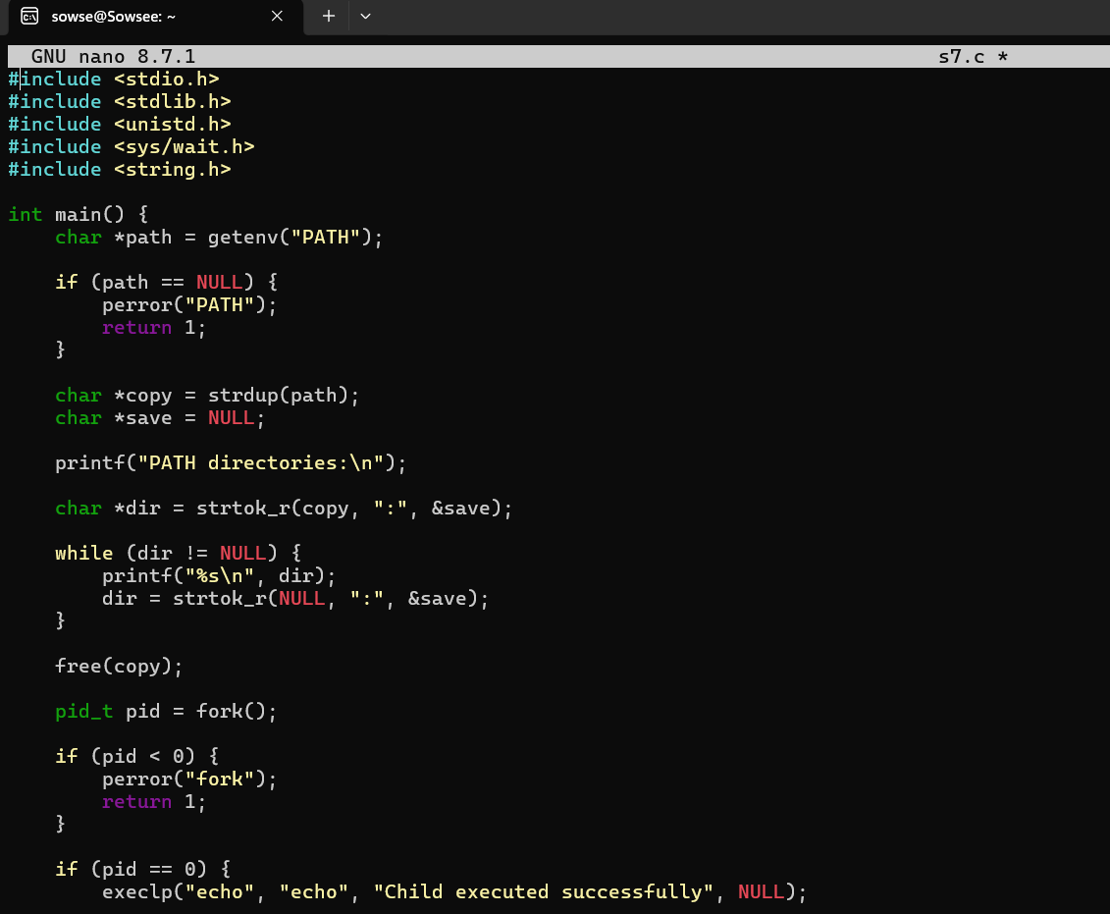
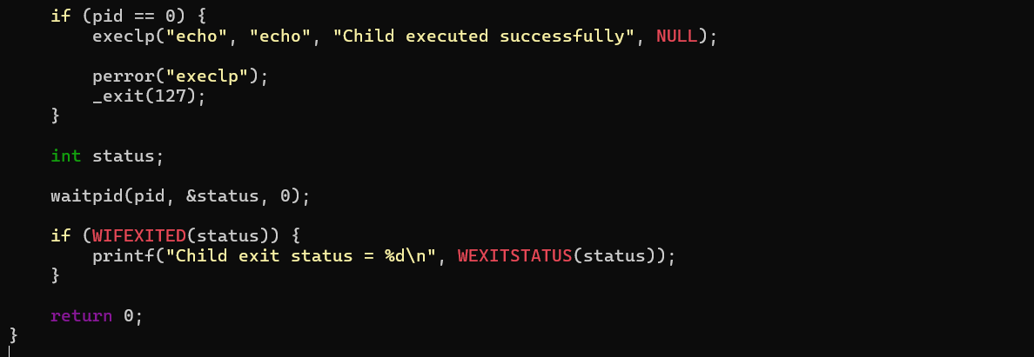
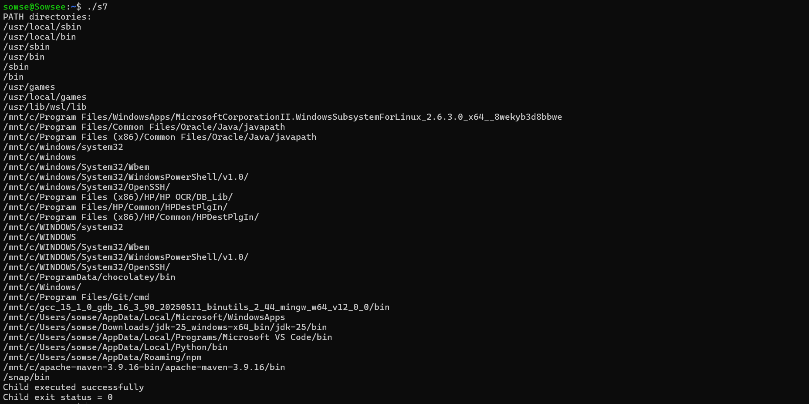

8. Variable Expansion and Built-in Command Dispatch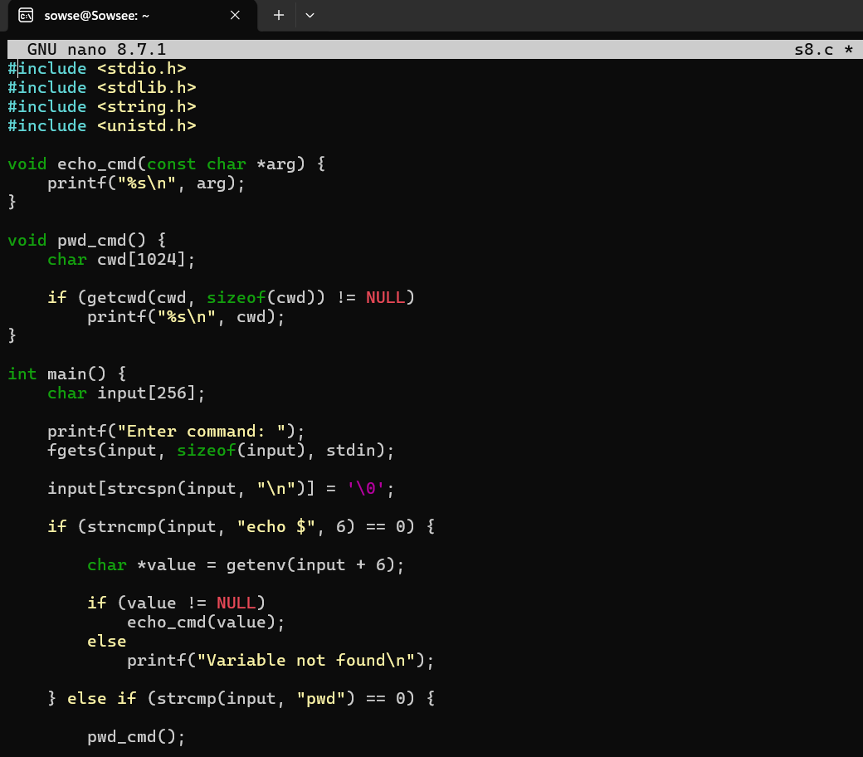

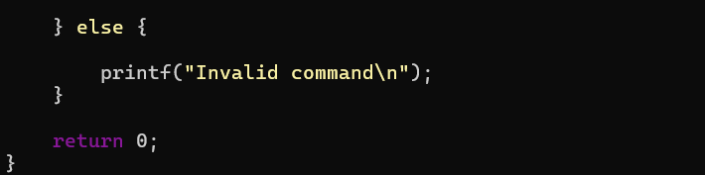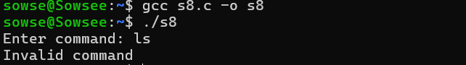

9. Changing Directories Using the cd Built-in
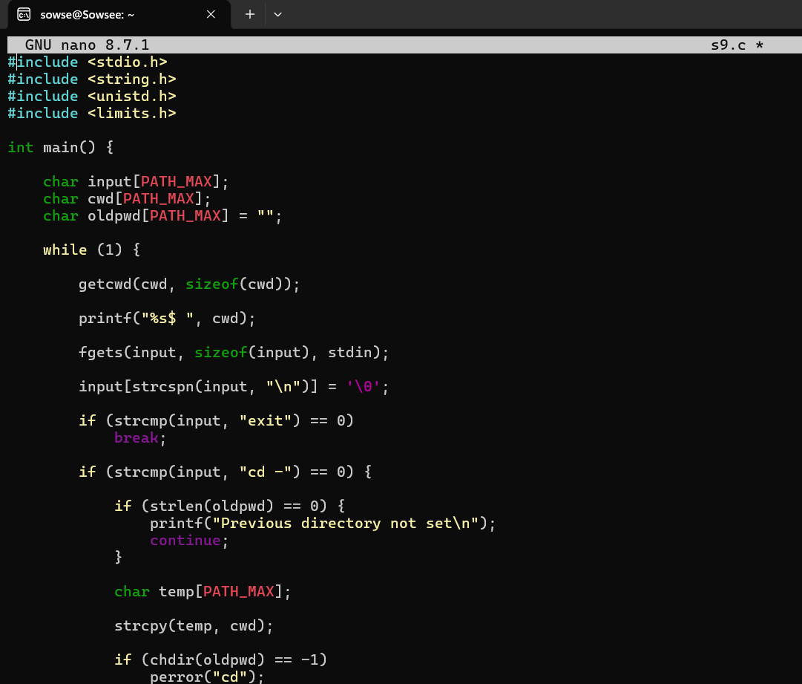
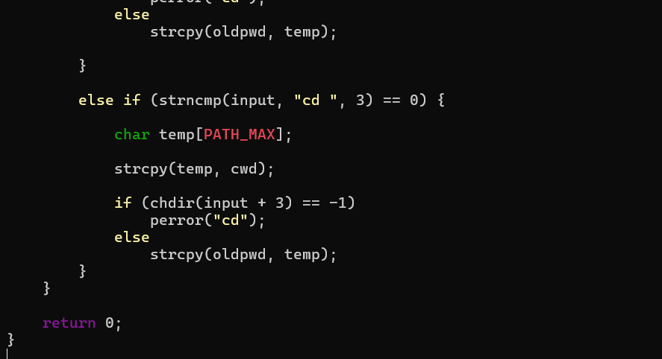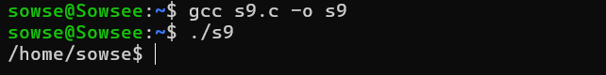

10. Current Directory, Exit Requests, and Exporting Environment Variables
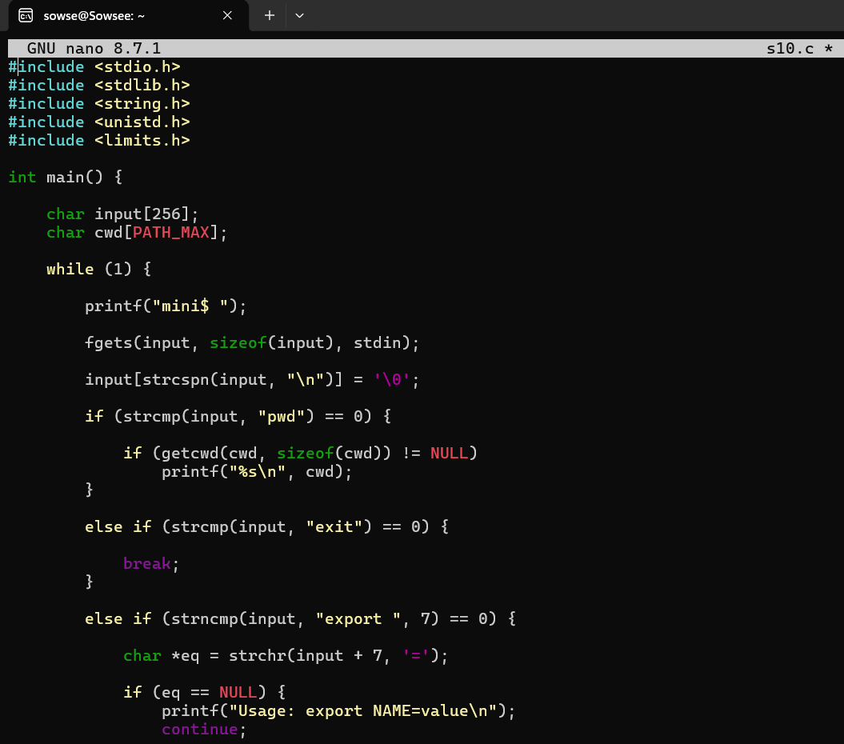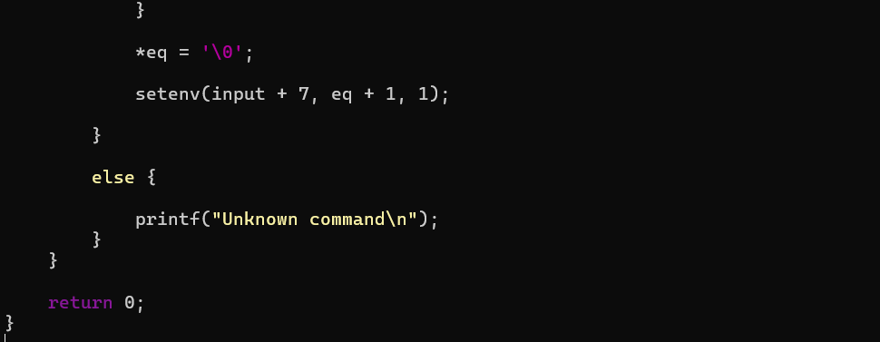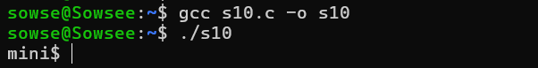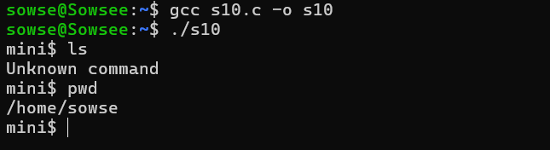

11. Command History and Pipeline Structures

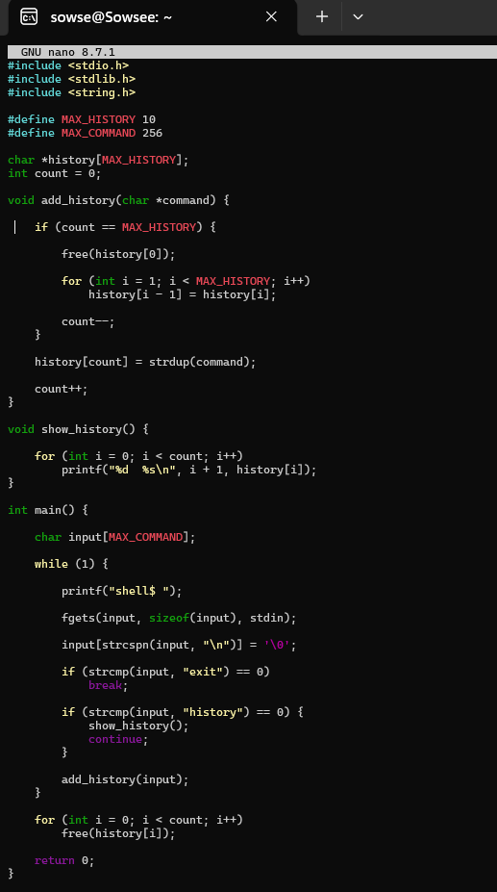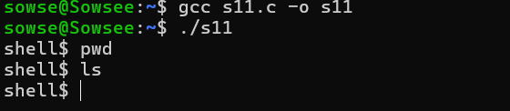
12. Pipes, Stream Redirection, and Connected Command Execution
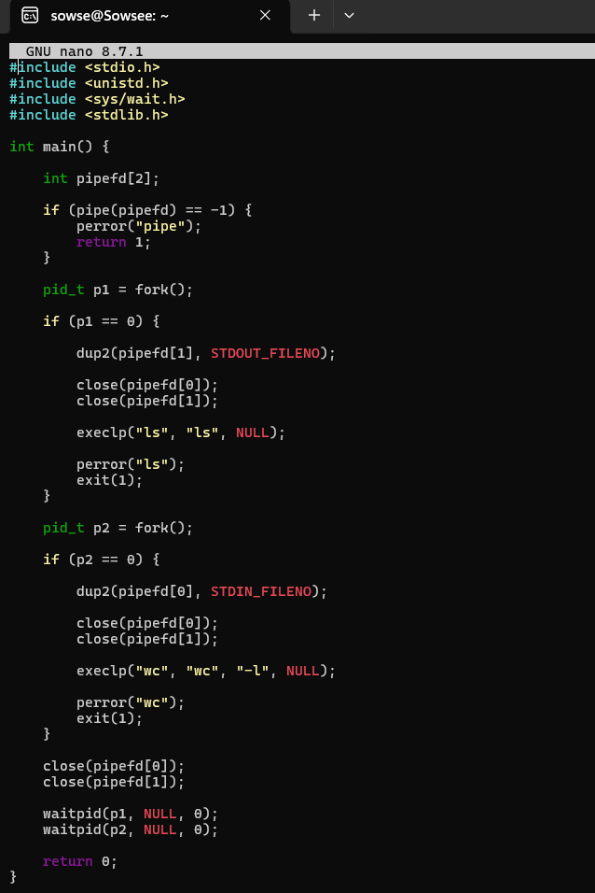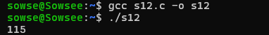

13. Input Redirection Using <
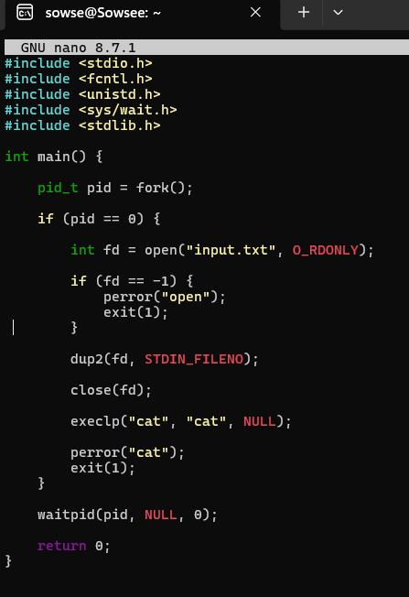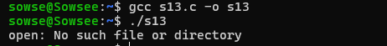

14. Output Redirection, Append Operator, and stderr Redirection
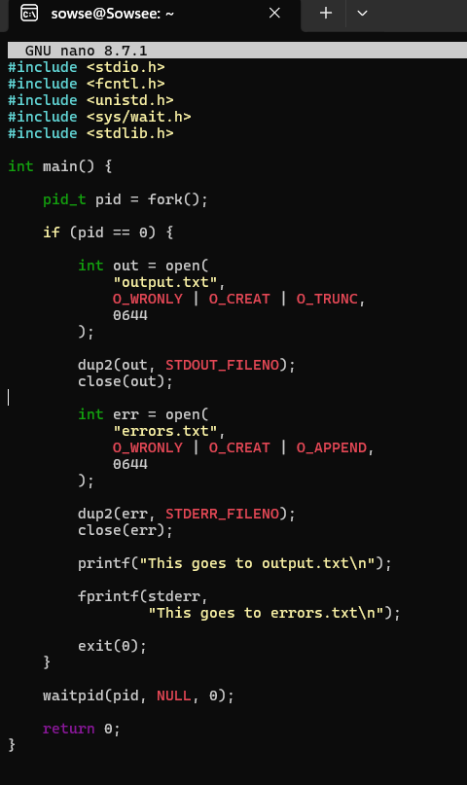

15. Combined Redirection of stdout and stderr
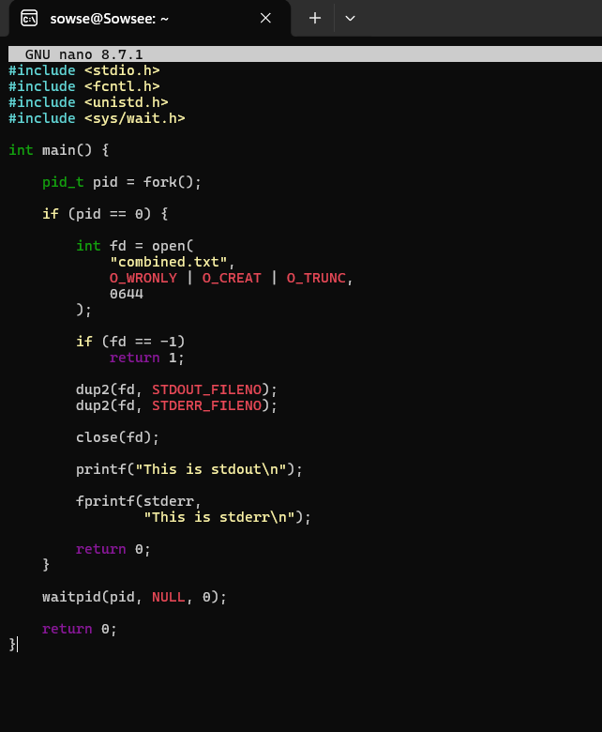

16. Background Jobs and Non-Blocking Processes
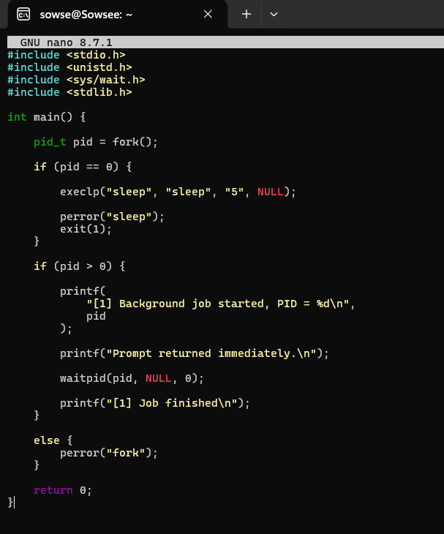

17. Job Listing and Foreground Job Switching
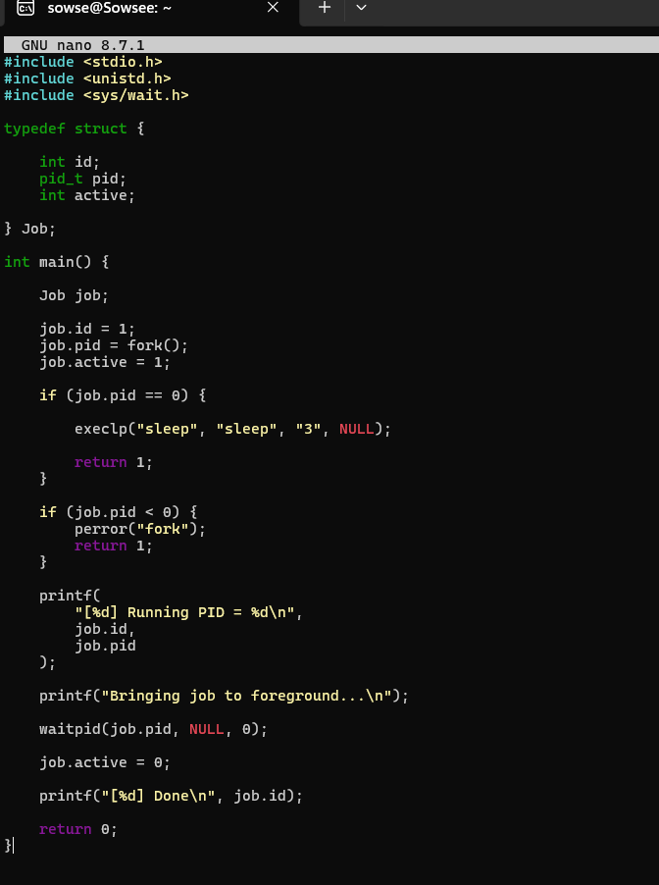

18. Signal Delivery, Signal Masks, Process Groups, and Resuming Stopped Jobs
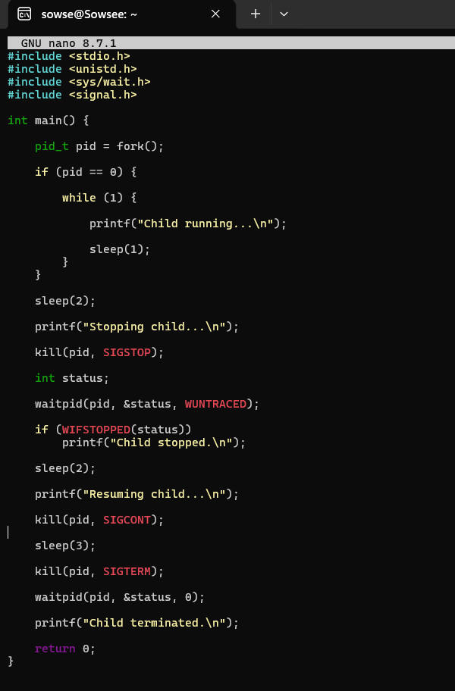

19. Signal Handlers, SIGINT, and Foreground Job Signal Forwarding
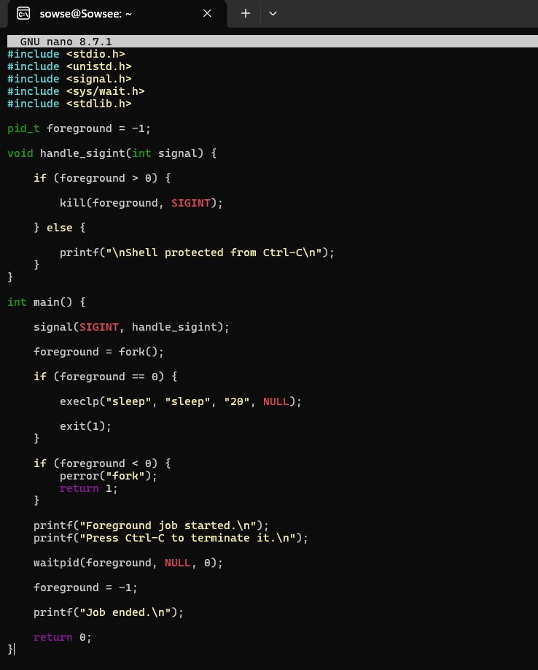

20. SIGTSTP, Process Suspension, Process Groups, and Terminal Control
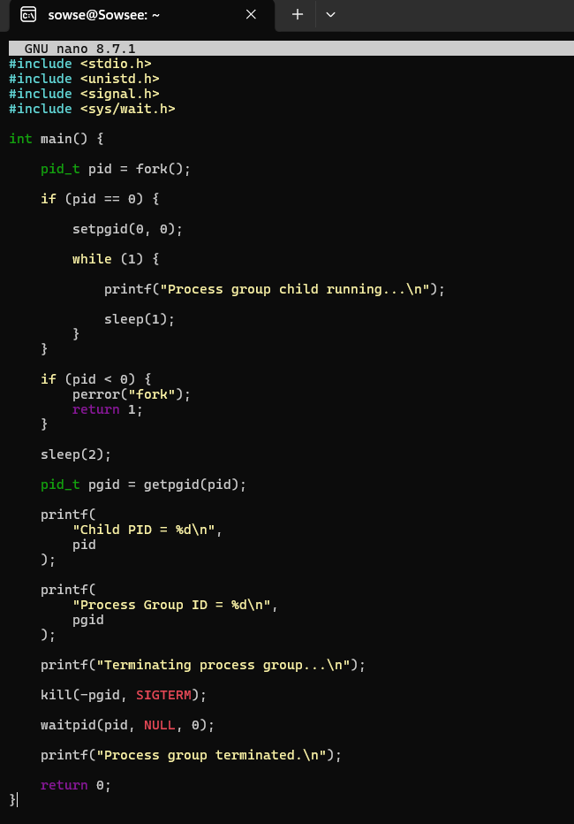

21. Connecting Modules, Interface Validation, Error Handling, and Reliability
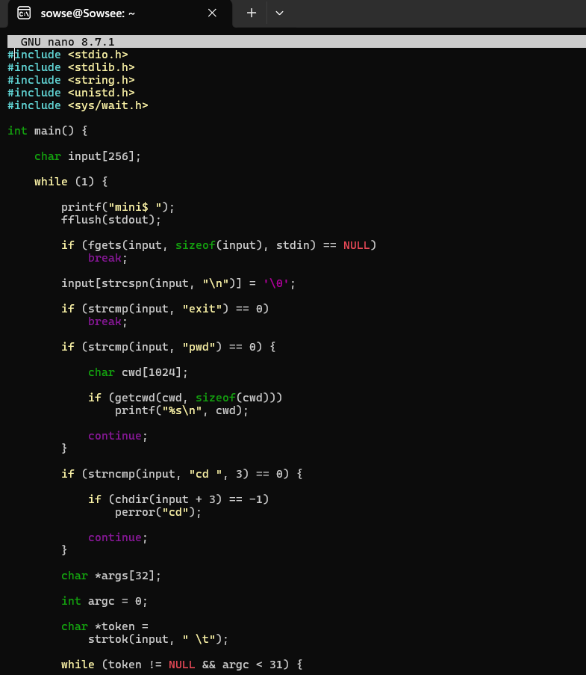
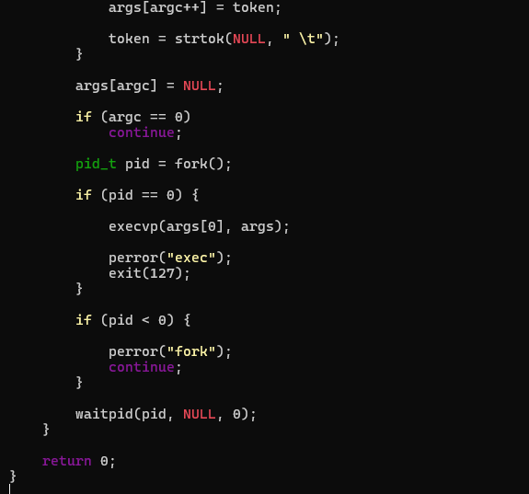

22. Valgrind, Memory Errors, Resource Cleanup, and Automated Testing
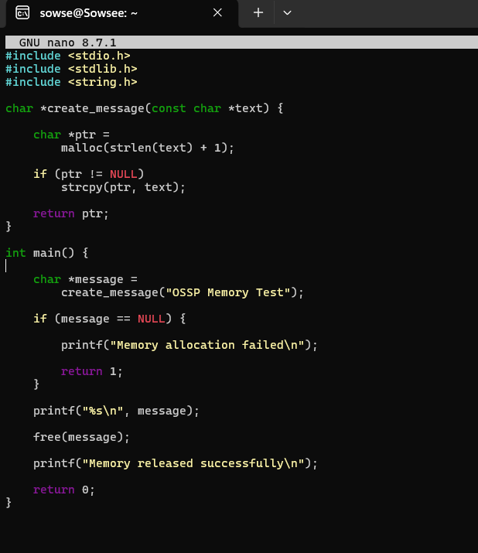

23. Large Pipelines, Multiple Jobs, Stability, Resource Monitoring, and Performance
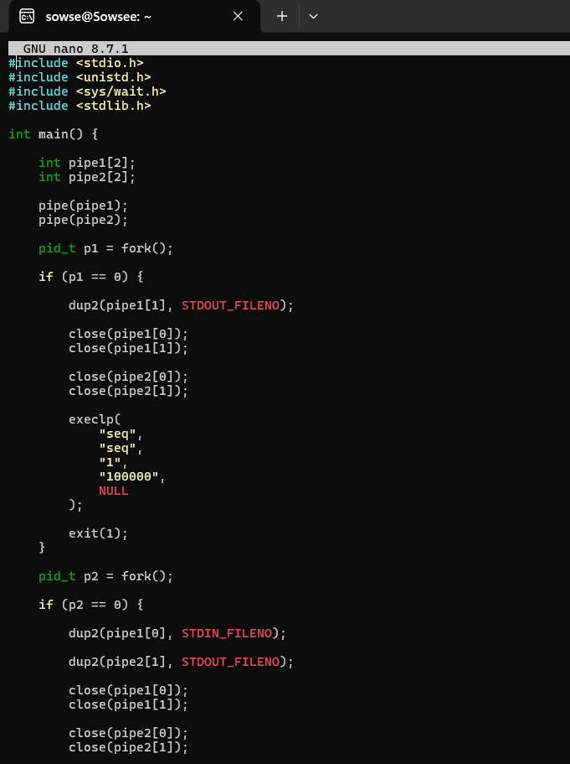
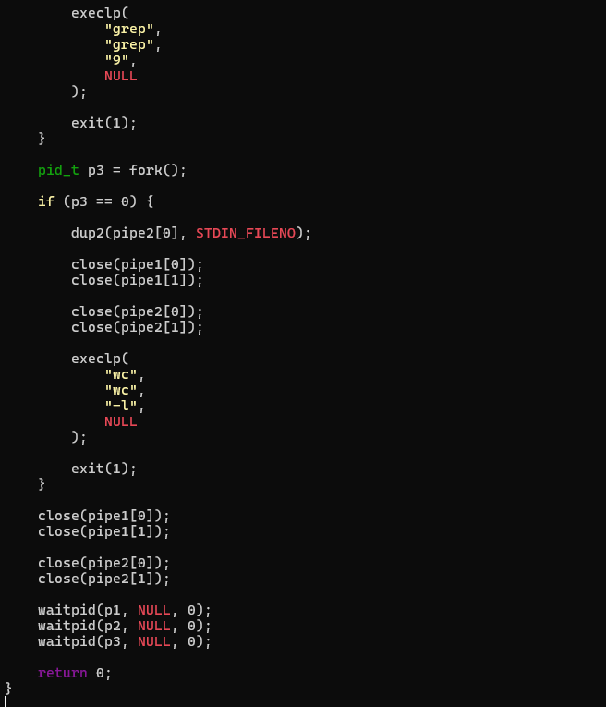

24. Architecture Documentation, Source Organization, Build Scripts, README, Releases, and Final Demo
